Electromagnetic interactions

Electromagnetic radiation transfers energy.
It is made of oscillating electric and magnetic fields.
In the photon model, radiation consists of small packets called photons.
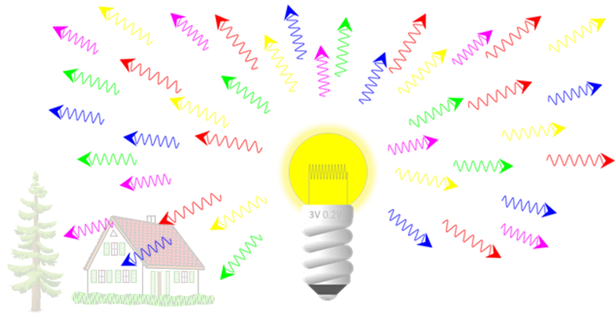
Electromagnetic radiation interacts with matter in different ways.
What does EM radiation not do to matter?
Put a tick () in the box next to the best answer.
A | Pass straight through some solids.
B | Move electrons through a conductor.
C | Pull electrons off atoms.
D | Knock atoms off solids.

Physics > Big idea PSL: Sound, light and waves > Topic PSL7: Electromagnetic waves > Key concept PSL7.2: Electromagnetic spectrum
Diagnostic question
Electromagnetic interactions

Overview
Learning focus: | Electromagnetic radiation transfers energy and interacts with matter in different ways, depending on the frequency and matter. Each radiation type can be both helpful and harmful.
Observable learning outcome: | Describe some ways in which electromagnetic radiation can interact with matter.
Question type: | Simple multiple choice
Key words: | Radiation, matter, oscillating, electric field, magnetic field, photon, conductor, ionisation

What does the research say?
Students often confuse EM radiation with particle radiation, which includes alpha or beta particles (Plotz, 2017). The majority of students aged 12-18 (n=1246) also find it hard to distinguish between ionising and non-ionising radiation (Rego and Peralta, 2006).
Some text books describe ionisation as photons knocking outer electrons off atoms, and the interpretation often made by students is that the photons need to physically collide with electrons, which they don’t. Ionising EM radiation can cause outer electrons to be forced out of atoms, by attraction or repulsion between the electric field of an electron and that of the radiation, in turn affecting bonds and interactions between atoms. Some types of EM radiation are ionising and other types are not.
It is common for students to think that when an object is exposed to radiation that it becomes radioactive. However, this is only true for high-energy gamma radiation that may excite atomic nuclei (Plotz, 2017).
Ways to use this question
Students should complete the question individually. This could be a pencil and paper exercise, or you could use an electronic ‘voting system’ or mini white boards and the PowerPoint presentation.
The answers to the question will show you whether students understood the concept sufficiently well to apply it correctly.
If there is a range of answers, you may choose to respond through structured class discussion. Ask one student to explain why they gave the answer they did; ask another student to explain why they agree with them; ask another to explain why they disagree, and so on. This sort of discussion gives students the opportunity to explore their thinking and for you to really understand their learning needs.

Differentiation
You may choose to read the questions to the class, so that everyone can focus on the science. In some situations, it may be more appropriate for a teaching assistant to read for one or two students.
Expected answer
D
How to respond - what next?
Some types of radiation can pass straight through some solids, such as light through glass (the majority of light photons pass through glass), radio waves can make electrons oscillate in an aerial and gamma radiation can pull electrons off atoms – all because of the way in which the electromagnetic fields of the photons interact with charged particles in matter.
A Students may perceive solid objects as impermeable in a way that radiation cannot pass straight through. A few students who realise that light can pass through glass may not consider light to be a type of radiation.
B Many students may be unfamiliar with the way that aerials work, with conducting electrons being made to resonate by an electromagnetic wave (that carries a radio signal).
C If students have the misunderstanding that electrons are knocked off atoms following a direct collision, they may not agree that electrons can be pulled off – by an electromagnetic attraction.
D Often students have the misunderstanding that all radiation is harmful and damaging, which they may take to mean knocking atoms off and eroding matter.
If students have misunderstandings about describing some ways in which electromagnetic radiation can interact with matter, it can help to provide students with the opportunity to research different types of EM radiation and to investigate the mechanisms by which each type interacts with matter – and how this can be both harmful and helpful, depending on the situation.
The following BEST ‘response activities’ could be used in follow-up to this diagnostic question:
- Response activity: Pulling electrons
- Response activity: Ready, steady, poster.
Acknowledgments
Developed by Peter Fairhurst (UYSEG).
Images: Peter Fairhurst (UYSEG), with house and tree by OpenClipart-Vectors from Pixabay.
References
Plotz, T. (2017). Students' conceptions of radiation and what to do about them. Physics Education, 52(1), 014004.
Rego, F. and Peralta, L. (2006). Portuguese students' knowledge of radiation physics. Physics Education, 41(3), 259.

