Natural radiation

There are seven broad types of electromagnetic radiation.
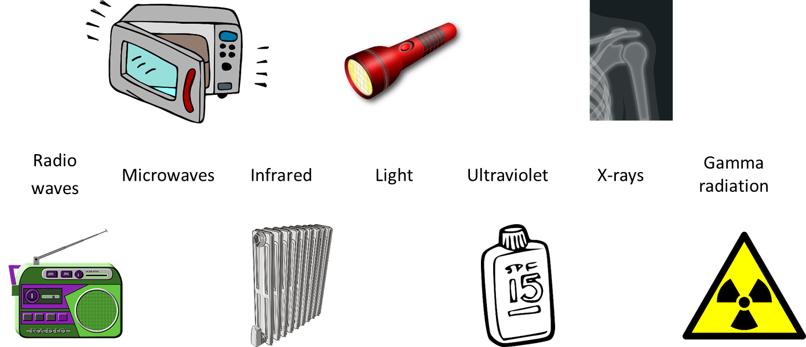
How is each type of EM radiation made?
To do: Put each type of electromagnetic radiation into one column.
Made artificially | Made naturally | Made artificially  and naturally

Physics > Big idea PSL: Sound, light and waves > Topic PSL7: Electromagnetic waves > Key concept PSL7.2: Electromagnetic spectrum
Diagnostic question
Natural radiation

Overview
Learning focus: | Electromagnetic radiation transfers energy and interacts with matter in different ways, depending on the frequency and matter. Each radiation type can be both helpful and harmful.
Observable learning outcome: | Identify types of electromagnetic radiation that can be naturally occurring.
Question type: | Linking ideas
Key words: | Radio waves, microwaves, infrared, light, ultraviolet, x-rays, gamma radiation, electromagnetic radiation, electromagnetic spectrum

What does the research say?
One of the most common misunderstandings about radiation is that it is artificial and a result of technological progress. Often students think that living far from urban or industrial areas reduces or even eliminates exposure to radiation (Neumann, 2014). It is therefore important to discuss natural occurrences of radiation (Neumann and Hopf, 2012), perhaps using an IR camera (or images taken by IR cameras) to demonstrate that even cold objects such as ice cubes emit IR radiation (Neumann, 2014).
In a study by Plotz and Fitzgerald (2021) most students (n=141) age 15-17 thought light and UV were both naturally occurring in the Sun. Most students also thought radio waves and X-rays were artificially produced, but for IR radiation, microwaves and gamma radiation there was no clear bias in opinion either way, probably because these EM radiation types were less familiar.
It is helpful perhaps, to notice that natural, as in naturally occurring, is a term that is often related to the idea of ‘not dangerous’ (Plotz, 2017).
Ways to use this question
This task is intended for discussion in pairs or small groups. It is best done as a pencil and paper exercise.
Students should follow the instructions on the worksheet. Listening in to the conversations of each group will often give you insights into how your students are thinking. Each member of a group should be able to report back to the class.
Feedback from each group can be used, with careful teacher questioning, to bring out a clear description or explanation of the science.
Differentiation
The quality of the discussions can be improved with a careful selection of groups; or by allocating specific roles to students in each group. For example, you may choose to select a student with strong prior knowledge as the scribe, and forbid them from contributing any of their own answers. They may question the others and only write down what they have been told. This strategy encourages contributions from more members of each group.
NB in any class, small group discussions typically improve over time and a persistence with this strategy is often very successful in the medium to long term.
Expected answers
All seven types of EM radiation are made artificially and naturally.
How to respond - what next?
It is common for students to have one or more of the following misunderstandings:
- some or all of the types of radiation are made only artificially
- all types of natural radiation come from the Sun
- only visible light and ultraviolet are naturally made
- radio waves and x-rays are not made naturally.
If students have misunderstandings about which types of electromagnetic radiation can be naturally occurring, it can help to investigate how each type of EM radiation can be made.
The following BEST ‘response activity’ could be used in follow-up to this diagnostic question:
- Response activity: Ready, steady, poster.
Acknowledgments
Developed by Peter Fairhurst (UYSEG).
Images: radio by alefonte, microwave oven by ArtRose, radiator by Painter06, torch by OpenClipard-Vectors, suncream by Clker-Free-Vector-Images, X-ray by marcmanhart and radiation warning symbol by Clker-Free-Vector-Images – all from Pixabay. Design by Peter Fairhurst (UYSEG).
References
Neumann, S. (2014). Three misconceptions about radiation—and what we teachers can do to confront them. The Physics Teacher, 52(6), 357-359.
Plotz, T. (2017). Students' conceptions of radiation and what to do about them. Physics Education, 52(1), 014004.
Plotz, T. and Fitzgerald, B. W. (2021). Superheroes of the Electromagnetic Spectrum: A Non-Traditional Way of Teaching Ionising Radiation. EURASIA Journal of Mathematics, Science and Technology Education, 17(6).

