Physics > Big idea PSL: Sound, light and waves > Topic PSL7: Electromagnetic waves
Key concept (age 14-16)
PSL7.2: Electromagnetic spectrum

What’s the big idea?
A big idea in physics is waves because it is the key to explaining how energy can be transferred from one object to another object by radiation, even when the objects are not touching. Waves carry information that can be detected by humans or manufactured detectors. Understanding waves helps us to communicate, explore the universe, and transfer energy to where we want it.
How does this key concept develop understanding of the big idea?
This key concept helps to develop the big idea by building on an understanding of the electromagnetic (EM) spectrum, in order to develop understanding of the properties of each type of EM radiation and how their sometimes-harmful properties can be used for helpful applications.
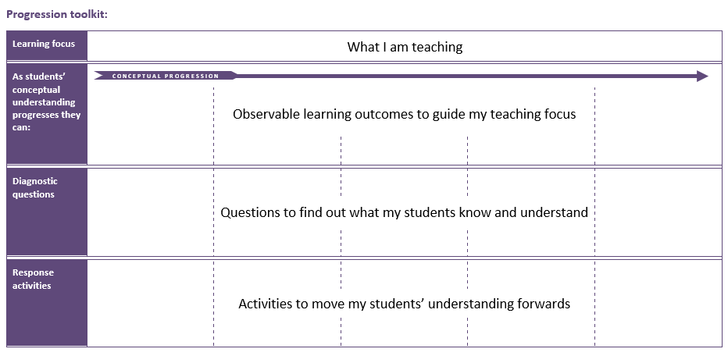
The conceptual progression starts by checking understanding that EM radiation is often naturally occurring, and that each type can used for helpful applications even if it can also be harmful. It then supports the development of an understanding of how different types of EM radiation interact with matter, including the mechanism for ionisation, in order to explain applications of EM radiation.
Using the progression toolkit to support student learning
Use diagnostic questions to identify quickly where your students are in their conceptual progression. Then decide how to best focus and sequence your teaching. Use further diagnostic questions and response activities to move student understanding forwards.
Progression toolkit: Electromagnetic spectrum
Learning focus | Electromagnetic radiation transfers energy and interacts with matter in different ways, depending on the frequency and matter. Each radiation type can be both helpful and harmful.
As students’ conceptual understanding progresses they can: | C o n c e p t u a l p r o g r e s s I o n
 | Identify types of electromagnetic radiation that can be naturally occurring. | Describe a range of sources of harmful electromagnetic radiation. | Describe some ways in which electromagnetic radiation can interact with matter. | Explain why some types of electromagnetic radiation are more ionising than others. | Apply understanding of ionising radiation to explain how radiotherapy works.
Diagnostic questions | Natural radiation | Bad radiation | Electromagnetic interactions | Most ionising
Response  activities |  |  | Pulling electrons |  | Radiotherapy
 | Ready, steady, poster

Key:
P | Prior understanding from earlier stages of learning | B | Bridge to later stages of learning

Natural radiation | Bad radiation | EM interactions | Most ionising | Pulling electrons
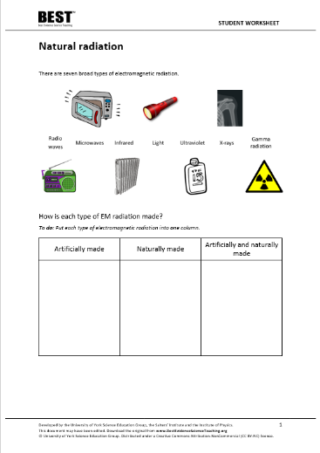 | 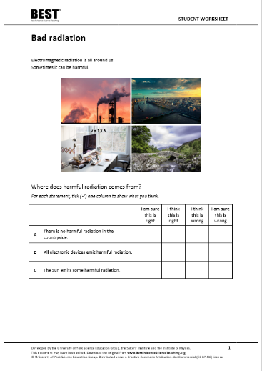 | 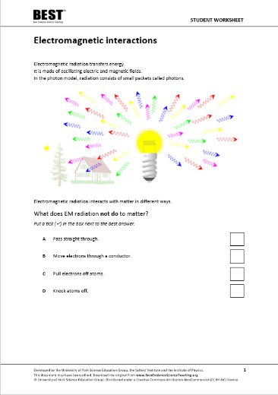 | 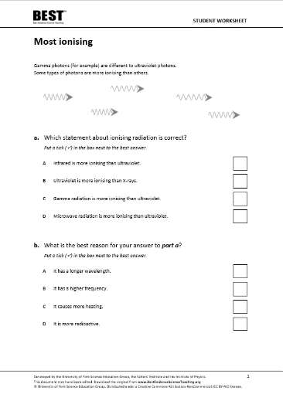 | 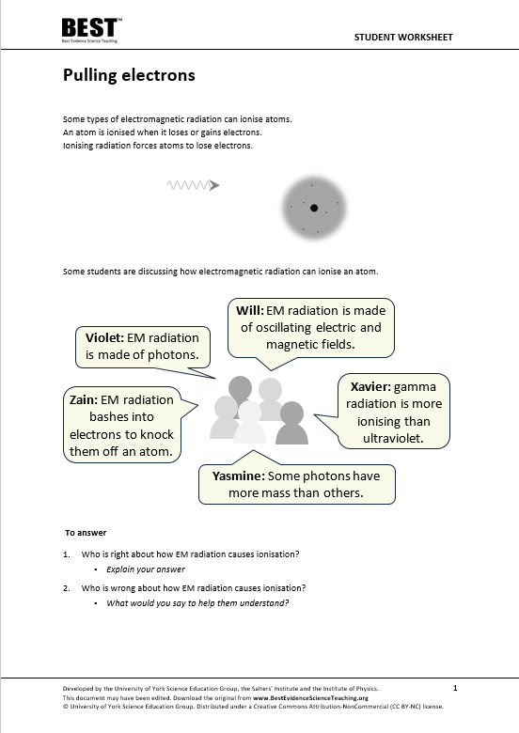
Linking ideas | Confidence grid | Simple multiple choice | Two-tier multiple choice | Talking heads
Radiotherapy | Ready, steady, poster
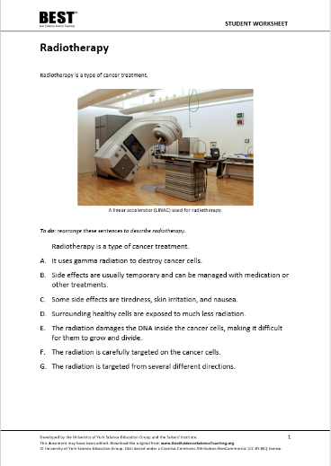 | 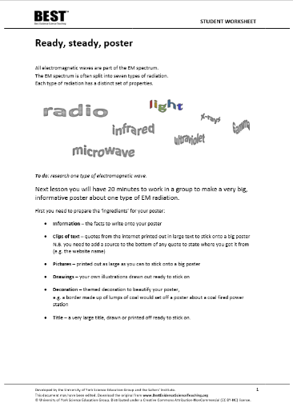
Sequencing | Application and practice

What’s the science story?
Different substances may absorb, transmit, refract, or reflect electromagnetic waves in ways that vary with wavelength. Radio waves can be produced by oscillations in electrical circuits and can themselves induce oscillations in electrical circuits. Because they can be transmitted and received, they can be used for communication.
Microwaves can also be used for communication and also for heating foods that contain water. Infrared is used for heating and infrared detectors help observe objects that are warmer or cooler than their surroundings. Ultraviolet can be used to make fluorescent materials glow so that security features on banknotes and credit cards can be seen. X-rays and gamma-rays can be used to observe the inner-workings of a human body. Ultraviolet waves, X-rays and gamma-rays can each have hazardous effects, notably on human bodily tissues.
Earlier development of understanding (BEST 11-14)
When applying their understanding to novel situations, students of all ages often revert to earlier misunderstandings. Before moving forward, it is worthwhile using diagnostic questions from earlier topics to check that students do not have any persistent misunderstandings that can form barriers to learning. Time spent consolidating the scientific understanding of earlier key concepts before moving forward can accelerate progression later.
Key concept PSL4.1: Waves on water and ropes
Learning focus: A transverse wave travelling across the surface of water (or along a rope) transfers energy, as particles of water (or rope) are successively made to vibrate at right angles to the direction in which the wave travels.
This key concept:
- Consolidates understanding that the medium through which a transverse wave is travelling does not move forward with the wave.
- Develops the understanding of how particles move in a transverse wave in order to propagate the wave.
- Develops an understanding that amplitude and frequency do not affect the speed of a transverse wave, and of why they do affect the rate at which transverse waves can transfer energy.

What does the research say?
In 2017, Plotz completed a review of research literature on students’ comprehension of electromagnetic (EM) radiation (1980 to 2017), from which he identified four concepts that he thought were necessary for a good understanding of the topic. He also identified understanding of wavelength, frequency and the propagation velocity of waves as prerequisites for learning.
The most important concept, he suggested, is the idea of how EM radiation is classified by frequency and ordered across the spectrum. His second concept complements this, which is that all EM radiation types have properties in common, including their speed in a vacuum. The third concept is that EM radiation is omnipresent, with all types in differing intensities surrounding us. The fourth is that EM radiation transfers energy and interacts with matter in different ways, depending on the wavelength and matter, and encompasses understanding of how each EM radiation type can be both helpful and harmful (Plotz, 2017).
Students often confuse EM radiation with particle radiation, which includes alpha or beta particles (Plotz, 2017). The majority of students aged 12-18 (n=1246) also find it hard to distinguish between ionising and non-ionising radiation (Rego and Peralta, 2006). Ionising EM radiation can cause outer electrons to be forced out of atoms, by attraction or repulsion between the electric field of an electron and that of the radiation, in turn affecting bonds and interactions between atoms. Some types of EM radiation are ionising and other types are not.
It is common for students to think that when an object is exposed to radiation that it becomes radioactive. However, this is only true for high-energy gamma radiation that may excite atomic nuclei (Plotz, 2017).
Radiation is often naturally occurring
One of the most common misunderstandings about radiation is that it is artificial and a result of technological progress. Often students think that living far from urban or industrial areas reduces or even eliminates exposure to radiation (Neumann, 2014). It is therefore important to discuss natural occurrences of radiation (Neumann and Hopf, 2012), perhaps using an infrared (IR) camera (or images taken by IR cameras) to demonstrate that even cold objects such as ice cubes emit IR radiation (Neumann, 2014).
In a study by Plotz and Fitzgerald (2021) most students (n=141) age 15-17 thought light and ultraviolet (UV) were both naturally occurring in the Sun. Most students also thought radio waves and X-rays were artificially produced, but for IR radiation, microwaves and gamma radiation there was no clear bias in opinion either way, probably because these EM radiation types were less familiar.
It is helpful perhaps, to notice that natural, as in naturally occurring, is a term that is often related to the idea of ‘not dangerous’ (Plotz, 2017).

Electromagnetic radiation can be both helpful and harmful
In a study by Plotz and Fitzgerald (2021) most students (n=141) age 15-17 thought light and radio waves were both safe. It is likely that some of these students did not consider either of these to be a form of radiation. Most students also thought that UV radiation and X-rays were dangerous.
Students often think that all radiation is harmful for living beings (Millar and Gill, 1996) and as a result, there is a widespread fear to any type of radiation and in any situation (Morales Lopez and Tuzon Marco, 2021). This may, in part, be linked to lots of misunderstandings about EM radiation being circulated via inaccurate reports in the media. For example, in one analysis of 200 websites that contained information about radiation and radioactivity, 38% included misleading information. The misleading information typically described radiation as not natural and always harmful, with mobile phones, radios, televisions and other electrical devices often quoted as sources of harmful radiation (Acar Sesen and Ince, 2010).
In a survey of fifty 14- to 16-year-olds Neumann and Hopf (2012) found the majority had negative feelings about radiation, with only 16% having broadly positive feelings about it. Students also tend to think about there being two types of radiation, namely ‘good radiation’ and ‘bad radiation’. They do not generally recognise that each type of radiation can be both helpful and harmful (Plotz, 2017).
Neumann (2014) recommends the same emphasis should be put on beneficial applications of radiation as on its potentially harmful effects. For example, she suggests that students should identify both pros and cons of each type of radiation to emphasise that most things are neither wholly harmful nor helpful.
Whether a particular type of EM radiation is harmful or not can depend on its intensity. For example, high intensity light from a laser can damage a person’s eye, but for normal intensities is quite safe. Students often explain the danger of radiation by referring to the size of dose, or intensity, but not to the ionising energy of the radiation, which is important when comparing different types of EM radiation (Plotz, 2017).
References
Acar Sesen, B. and Ince, E. (2010). Internet as a source of misconception. Turkish Online Journal of Educational Technology-TOJET, 9(4), 94-100.
Millar, R. and Gill, J. S. (1996). School students' understanding of processes involving radioactive substances and ionizing radiation. Physics Education, 31, 27-33.
Morales Lopez, A. I. and Tuzon Marco, P. (2021). Misconceptions, Knowledge, and Attitudes Towards the Phenomenon of Radioactivity. Science & Education.
Neumann, S. (2014). Three misconceptions about radiation—and what we teachers can do to confront them. The Physics Teacher, 52(6), 357-359.
Neumann, S. and Hopf, M. (2012). Students’ conceptions about ‘radiation’: Results from an explorative interview study of 9th grade students. Journal of Science Education and Technology, 21, 826-834.
Plotz, T. (2017). Students' conceptions of radiation and what to do about them. Physics Education, 52(1), 014004.
Plotz, T. and Fitzgerald, B. W. (2021). Superheroes of the Electromagnetic Spectrum: A Non-Traditional Way of Teaching Ionising Radiation. EURASIA Journal of Mathematics, Science and Technology Education, 17(6).
Rego, F. and Peralta, L. (2006). Portuguese students' knowledge of radiation physics. Physics Education, 41(3), 259.

