Radiotherapy

Radiotherapy is a type of cancer treatment.
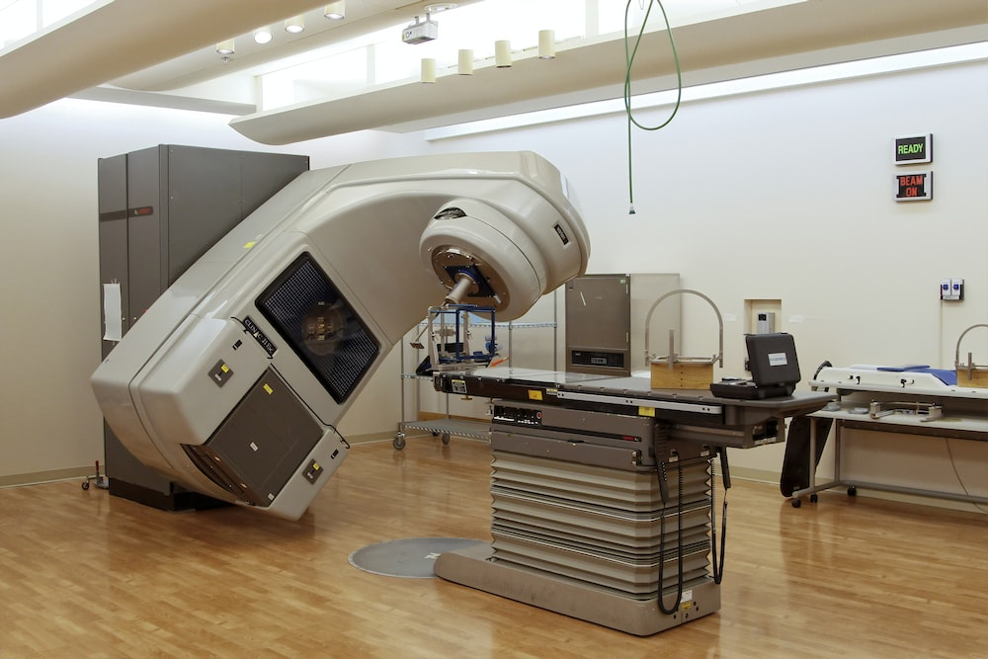
A linear accelerator (LINAC) used for radiotherapy.
To do: rearrange these sentences to describe radiotherapy.
Radiotherapy is a type of cancer treatment.
A. It uses gamma radiation to destroy cancer cells.
B. Side effects are usually temporary and can be managed with medication or other treatments.
C. Some side effects are tiredness, skin irritation, and nausea.
D. Surrounding healthy cells are exposed to much less radiation.
E. The radiation damages the DNA inside the cancer cells, making it difficult for them to grow and divide.
F. The radiation is carefully targeted on the cancer cells.
G. The radiation is targeted from several different directions.

Sort cards for: Radiotherapy
Radiotherapy is a type of cancer treatment.
A. It uses gamma radiation to destroy cancer cells.
B. Side effects are usually temporary and can be managed with medication or other treatments.
C. Some side effects are tiredness, skin irritation, and nausea.
D. Surrounding healthy cells are exposed to much less radiation.
E. The radiation damages the DNA inside the cancer cells, making it difficult for them to grow and divide.
F. The radiation is carefully targeted on the cancer cells.
G. The radiation is targeted from several different directions.

Sort cards for: Radiotherapy
Radiotherapy is a type of cancer treatment.
A. It uses gamma radiation to destroy cancer cells.
B. Side effects are usually temporary and can be managed with medication or other treatments.
C. Some side effects are tiredness, skin irritation, and nausea.
D. Surrounding healthy cells are exposed to much less radiation.
E. The radiation damages the DNA inside the cancer cells, making it difficult for them to grow and divide.
F. The radiation is carefully targeted on the cancer cells.
G. The radiation is targeted from several different directions.

Physics > Big idea PSL: Sound, light and waves > Topic PSL7: Electromagnetic waves > Key concept PSL7.2: Electromagnetic spectrum
Diagnostic activity
Radiotherapy

Overview
Learning focus: | Electromagnetic radiation transfers energy and interacts with matter in different ways, depending on the frequency and matter. Each radiation type can be both helpful and harmful.
Observable learning outcome: | Apply understanding of ionising radiation to explain how radiotherapy works.
Activity type: | Sequencing
Key words: | Radiotherapy, gamma radiation, cancer cell, linear accelerator (LINAC)

What does the research say?
In a survey of fifty 14- to 16-year-olds Neumann and Hopf (2012) found the majority had negative feelings about radiation, with only 16% having broadly positive feelings about it. Students also tend to think about there being two types of radiation, namely ‘good radiation’ and ‘bad radiation’. They do not generally recognise that each type of radiation can be both helpful and harmful (Plotz, 2017).
Neumann (2014) recommends the same emphasis should be put on beneficial applications of radiation as on its potentially harmful effects. For example, she suggests that students should identify both pros and cons of each type of radiation to emphasise that most things are neither wholly harmful nor helpful.
Whether a particular type of EM radiation is harmful or not can depend on its intensity. For example, high intensity light from a laser can damage a person’s eye, but for normal intensities is quite safe. Students often explain the danger of radiation by referring to the size of dose, or intensity, but not to the ionising energy of the radiation, which is important when comparing different types of EM radiation (Plotz, 2017).
Ways to use this activity
Students should complete the sequencing activity in pairs or small groups, and the focus should be on the discussions. The statements are also provided as cut-out cards for students to physically organise.
Listening in to the conversations of each group will often give you insights into how your students are thinking. Each member of a group should be able to explain why the statements were put in the chosen order. Once this activity has been completed it may be helpful to challenge students to independently write down their own description.
Differentiation
You may choose to use simplified statements for some students, or give them the starting statement to start them off. In some situations it may be more appropriate for a teaching assistant to read the statements with one or two students.
Expected answers
An appropriate order is:
Radiotherapy is a type of cancer treatment.
A. It uses gamma radiation to destroy cancer cells.
E. The radiation damages the DNA inside the cancer cells, making it difficult for them to grow and divide.
F. The radiation is carefully targeted on the cancer cells.
G. The radiation is targeted from several different directions.
D. Surrounding healthy cells are exposed to much less radiation.
C. Some side effects are tiredness, skin irritation, and nausea.
B. Side effects are usually temporary and can be managed with medication or other treatments.
Acknowledgments
Developed by Peter Fairhurst (UYSEG).
Image: National Cancer Institute from Unsplash
References
Neumann, S. (2014). Three misconceptions about radiation—and what we teachers can do to confront them. The Physics Teacher, 52(6), 357-359.
Neumann, S. and Hopf, M. (2012). Students’ conceptions about ‘radiation’: Results from an explorative interview study of 9th grade students. Journal of Science Education and Technology, 21, 826-834.
Plotz, T. (2017). Students' conceptions of radiation and what to do about them. Physics Education, 52(1), 014004.

