Ready, steady, poster

All electromagnetic waves are part of the EM spectrum.
The EM spectrum is often split into seven types of radiation.
Each type of radiation has a distinct set of properties.
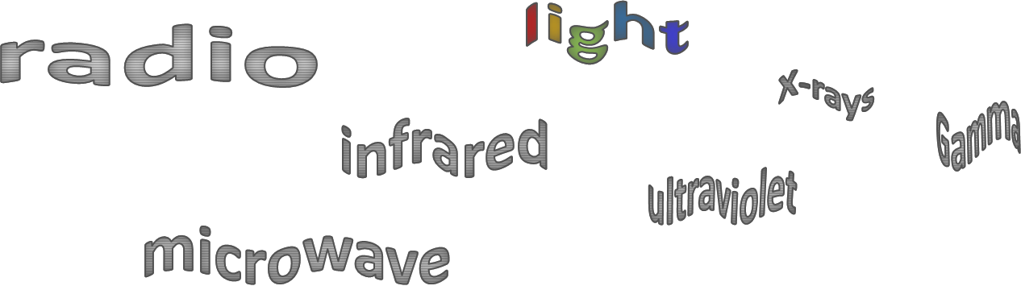
To do: research one type of electromagnetic wave.
Next lesson you will have 20 minutes to work in a group to make a very big, informative poster about one type of EM radiation.
First you need to prepare the ‘ingredients’ for your poster:
- Information – the facts to write onto your poster
- Clips of text – quotes from the internet printed out in large text to stick onto a big poster
N.B. you need to add a source to the bottom of any quote to state where you got it from (e.g. the website name)
- Pictures – printed out as large as you can to stick onto a big poster
- Drawings – your own illustrations drawn out ready to stick on
- Decoration – themed decoration to beautify your poster,
e.g. a border made up of lumps of coal would set off a poster about a coal fired power station
- Title – a very large title, drawn or printed off ready to stick on.

Why do these precautions work?
How can we keep safe from this radiation?
What are its dangers (if any)?
What are its properties that make it useful?
What can it be used for?
Type of  EM radiation | Radio wave radiation | Microwave radiation | Infrared radiation | Light radiation | Ultraviolet radiation | X-ray radiation | Gamma radiation
Ready, steady, poster
Gamma Radiation
Research and prepare items for your poster on:
- The speed, frequency and wavelength of gamma radiation.
- How gamma radiation is made (and/or what makes it)
  - Gamma rays originate from changes in the nucleus of an atom.
- How it can be helpful
  - e.g. medical imaging and treatments.
- What dangers there are (if any) and how they can be avoided
  - e.g. X-rays and gamma rays are ionising radiation that can cause the mutation of genes and cancer
  - N.B. ultraviolet waves, X-rays and gamma rays can have hazardous effects on human body tissue. The effects depend on the type of radiation and the size of the dose
  - Radiation dose (in sieverts) is a measure of the risk of harm resulting from an exposure of the body to the radiation
  - 1000 millisieverts (mSv) = 1 sievert (Sv).
- Some other interesting facts.

Ready, steady, poster
X-ray radiation
Research and prepare items for your poster on:
- The speed, frequency and wavelength of x-ray radiation.
- How x-ray radiation is made (and/or what makes it).
- How it can be helpful
  - e.g. medical imaging and treatments.
- What dangers there are (if any) and how they can be avoided
  - e.g. X-rays and gamma rays are ionising radiation that can cause the mutation of genes and cancer.
  - N.B. ultraviolet waves, X-rays and gamma rays can have hazardous effects on human body tissue. The effects depend on the type of radiation and the size of the dose.
  - Radiation dose (in sieverts) is a measure of the risk of harm resulting from an exposure of the body to the radiation.
  - 1000 millisieverts (mSv) = 1 sievert (Sv).
- Some other interesting facts.

Ready, steady, poster
Ultraviolet Radiation
Research and prepare items for your poster on:
- The speed, frequency and wavelength of ultraviolet radiation.
- How ultraviolet radiation is made (and/or what makes it).
- How it can be helpful.
  - e.g. energy efficient lamps, sun tanning, security codes on property.
- What dangers there are (if any) and how they can be avoided
  - e.g. ultraviolet waves can cause skin to age prematurely and increase the risk of skin cancer.
  - NB ultraviolet waves, X-rays and gamma rays can have hazardous effects on human body tissue. The effects depend on the type of radiation and the size of the dose.
- Some other interesting facts

Ready, steady, poster
Light Radiation
Research and prepare items for your poster on:
- The speed, frequency and wavelength of light radiation.
- How light radiation is made (and/or what makes it).
- How it can be helpful
  - e.g. fibre optic communications
  - NB our eyes only detect visible light and so detect a limited range of electromagnetic waves.
- What dangers there are (if any) and how they can be avoided
  - e.g. laser pointers.
- Some other interesting facts.

Ready, steady, poster
Infrared Radiation
Research and prepare items for your poster on:
- The speed, frequency and wavelength of infrared radiation.
- How infrared radiation is made (and/or what makes it).
- How it can be helpful
  - e.g. electrical heaters, cooking food, infrared cameras.
- What dangers there are (if any) and how they can be avoided.
- Some other interesting facts.

Ready, steady, poster
Microwave Radiation
Research and prepare items for your poster on:
- The speed, frequency and wavelength of microwave radiation.
- How microwave radiation is made (and/or what makes it).
- How it can be helpful
  - e.g. satellite communications, cooking food.
- What dangers there are (if any) and how they can be avoided
  - What absorbs microwaves to stop them escaping from a microwave oven?
- Some other interesting facts.

Ready, steady, poster
Radio wave Radiation
Research and prepare items for your poster on:
- The speed, frequency and wavelength of radio wave radiation.
- How radio wave radiation is made (and/or what makes it)
  - Radio waves can be produced by oscillations in electrical circuits.
- How it can be helpful
  - e.g. television and radio
  - give brief explanations why radio waves are suitable for these uses
  - N.B. when radio waves are absorbed they may create an alternating current with the same frequency as the radio wave itself, so radio waves can themselves induce oscillations in an electrical circuit.
- What dangers there are (if any) and how they can be avoided.
- Some other interesting facts.

Physics > Big idea PSL: Sound, light and waves > Topic PSL7: Electromagnetic waves > Key concept PSL7.2: Electromagnetic spectrum
Diagnostic activity
Ready, steady, poster

Overview
Learning focus: | Electromagnetic radiation transfers energy and interacts with matter in different ways, depending on the frequency and matter. Each radiation type can be both helpful and harmful.
Observable learning outcome: | Identify types of electromagnetic radiation that can be naturally occurring.  Describe a range of sources of harmful electromagnetic radiation.  Describe some ways in which electromagnetic radiation can interact with matter.  Explain why some types of electromagnetic radiation are more ionising than others.  Apply understanding of ionising radiation to explain how radiotherapy works.
Activity type: | Application and practice
Key words: | Electromagnetic spectrum, gamma, x-ray, ultraviolet, light, infrared, microwave, radio, frequency, wavelength, energy

What does the research say?
In 2017, Plotz completed a review of research literature on students’ comprehension of electromagnetic (EM) radiation (1980 to 2017), from which he identified four concepts that he thought were necessary for a good understanding of the topic. He also identified understanding of wavelength, frequency and the propagation velocity of waves as prerequisites for learning.
The most important concept, he suggested, is the idea of how EM radiation is classified by wavelength and ordered across the spectrum. His second concept complements this, which is that all EM radiation types have properties in common, including their speed in a vacuum. The third concept is that EM radiation is omnipresent, with all types in differing intensities surrounding us. The fourth is that EM radiation transfers energy and interacts with matter in different ways, depending on the wavelength and matter, and encompasses understanding of how each EM radiation type can be both helpful and harmful (Plotz, 2017).
Neumann (2014) recommends the same emphasis should be put on beneficial applications of radiation as on its potentially harmful effects. For example, she suggests that students should identify both pros and cons of each type of radiation to emphasise that most things are neither wholly harmful nor helpful.
Whether a particular type of EM radiation is harmful or not can depend on its intensity. For example, high intensity light from a laser can damage a person’s eye, but for normal intensities is quite safe. Students often explain the danger of radiation by referring to the size of dose, or intensity, but not to the ionising energy of the radiation, which is important when comparing different types of EM radiation (Plotz, 2017).
Ways to use this activity
This activity gives students the opportunity to practise applying their understanding and to clarify their thinking through discussion. To support this, students should complete the activity in pairs or small groups.
This particular activity can be introduced during one lesson and completed in the next. Research and preparation may be completed individually as a homework activity.
- In the first part of the activity, students research one type of electromagnetic radiation thoroughly and prepare items with which to contribute to making a large poster.
  - It is helpful to show students the size of poster they will be making before they begin.
- Worksheets provide students with guidance and prompts for what to look for. Roughly equal numbers of students should research each type of EM radiation.
- To make the posters, students come together in groups comprising those who researched each type of radiation. Students in each group sort and consolidate their resources in order to make the best poster they can in 20 minutes.
- There is a 20-minute timer on the PowerPoint for this activity.
- After completing the posters, students each summarise the information on all the posters made by the class using a summary table provided on the worksheets.
- Follow up work can further explore patterns in wavelength, frequency, energy and ionising power across the EM spectrum.
Listening to individual groups as they work often highlights any difficulties they might have. These can often be overcome, through a whole class clarification or redirection part way through the activity.
Differentiation
Groups may be organised to provide the best working groups for the class. It may be appropriate to make the research task more focused, or to provide fill-in sheets for some in order to complete the research phase.
Equipment
For posters:
- Large sheets of coloured backing paper
- Scissors
- Marker pens
- Paper glue

Expected answers
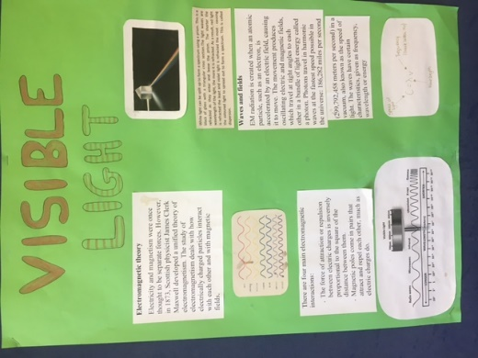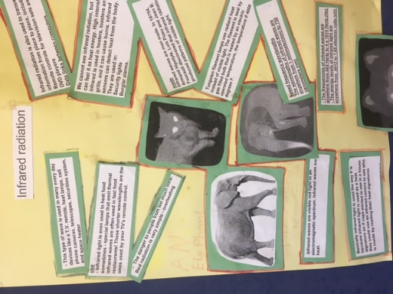
Acknowledgments
Developed by Peter Fairhurst (UYSEG).
Images by Peter Fairhurst (UYSEG).
References
Neumann, S. (2014). Three misconceptions about radiation—and what we teachers can do to confront them. The Physics Teacher, 52(6), 357-359.
Plotz, T. (2017). Students' conceptions of radiation and what to do about them. Physics Education, 52(1), 014004.

