*Physics > Big idea PEM: Electricity and magnetism > Topic PEM8: Mains electricity*

|  |
| --- |
| **Key concept (age 14-16)** |
| **PEM8.3: Transmitting electricity** |

**What’s the big idea?**

A big idea in physics is electricity and magnetism. The familiar everyday world we live in is largely a consequence of the properties and behaviour of electric charge. Matter is held together by electrostatic forces, and these influence chemical changes. Electricity and magnetism initially seem distinct phenomena but are later found to be closely interrelated. Understanding electricity and magnetism helps us to develop our technology and find applications that can transform our everyday lives.

**How does this key concept develop understanding of the big idea?**

This key concept helps to develop the big idea by reviewing ideas about power and power dissipation, and developing understanding of how these ideas can be applied to transmission lines. 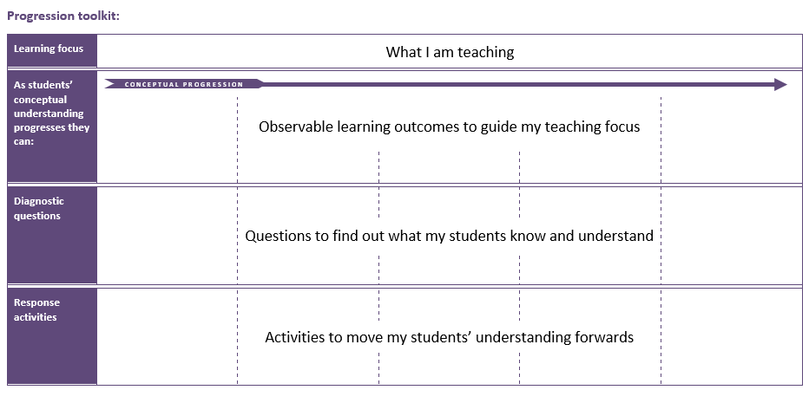The conceptual progression starts by checking understanding of the heating effect of current. It then supports development of the understanding of how to calculate power transmitted and power dissipated by transmission lines. The difference between transmission voltage and the voltage across the length of transmission lines is clarified and opportunity provided to apply this understanding.

**Using the progression toolkit to support student learning**

Use diagnostic questions to identify quickly where your students are in their conceptual progression. Then decide how to best focus and sequence your teaching. Use further diagnostic questions and response activities to move student understanding forwards.

**Progression toolkit: Transmitting Electricity**

|  |  |  |  |  |  |
| --- | --- | --- | --- | --- | --- |
| **Learning focus** | Transmission lines dissipate less power when they transfer power with a higher transmission voltage and lower current. When current is lower there is a smaller drop in voltage along their length. | | | | |
|  |  |  |  |  |  |
| **As students’ conceptual understanding progresses they can:** | **C o n c e p t u a l p r o g r e s s I o n** | | | | |
| Describe the heating effect of current on a conducting wire.  **P** | Predict changes to current through transmission lines using P = I x V. | Calculate power dissipated by a wire using P = I2 x R. | Explain the difference between transmission voltage and voltage drop along a wire. | Explain how the equation P = V2/R applies to transmission lines.  **B** |
|  |  |  |  |  |  |
| **Diagnostic questions** | Hot line | Transmission current | Power dissipation | The right voltage | The right power |
|  |  |  |  |  |  |
| **Response**  **activities** |  | Transmission lines | | Talking volts | |

|  |  |  |  |  |  |  |  |  |  |  |  |
| --- | --- | --- | --- | --- | --- | --- | --- | --- | --- | --- | --- |
| |  |  |  |  | | --- | --- | --- | --- | | Key: | | | | | **P** | Prior understanding from earlier stages of learning | **B** | Bridge to later stages of learning | | | | |
|  |  |  |  |

|  |  |  |  |  |
| --- | --- | --- | --- | --- |
| **Hot line** | **Transmission current** | **Power dissipation** | **The right voltage** | **The right power** |
|  |  |  |  |  |
| Confidence grid | Simple multiple choice | Simple multiple choice | Simple multiple choice | Confidence grid |
| **Transmission lines** | **Talking volts** |  |  |  |
|  |  |  |  |  |
| PEOE  Predict, explain; observe, explain | Talking heads |  |  |  |

**What’s the science story?**

The National Grid uses transformers to step down the current for power transmission. The power output from a transformer cannot be greater than the power input, therefore if the current decreases, the potential difference must increase. Transmitting power with a lower current through the cables results in less power being dissipated during transmission.

**Earlier development of understanding (BEST 11-14)**

When applying their understanding to novel situations, students of all ages often revert to earlier misunderstandings. Before moving forward, it is worthwhile using diagnostic questions from earlier topics to check that students do not have any persistent misunderstandings that can form barriers to learning. Time spent consolidating the scientific understanding of earlier key concepts before moving forward can accelerate progression later.

|  |
| --- |
| **Key concept PEM 5.1 Analysing series circuits**  **Learning focus:** Rules for current and potential difference around a circuit and the equation I = V/R can be used to calculate values of current, potential difference and resistance in series circuits.  This key concept:   * Reviews the rules for current and potential difference in a series circuit * Develops understanding of the equation I = V/R * Applies understanding of the relationship between current, potential difference and resistance to the systematic analysis of series circuits. |
|  |
| **Key concept PEM 5.2 Analysing parallel circuits**  **Learning focus:** Rules for current and potential difference around a circuit and the equation I = V/R can be used to calculate values of current, potential difference and resistance in parallel circuits.  This key concept:   * Reviews the rules for current and potential difference in a parallel circuit * Develops strategies for using the equation I = V/R for the systematic analysis of parallel circuits. * Applies understanding of the relationship between current, potential difference and resistance to explain changes in complex parallel circuits. |

**What does the research say?**

Students often readily accept that power dissipation from electricity transmission lines is reduced when transmission voltage is high and transmission current is low. This can be explained by combining the equations P = I x V and V = I x R to show that power dissipation = I2 x R, which shows that power dissipation increases rapidly with current. The power dissipation for different currents through a conducting resistance wire, such as nichrome, can be readily demonstrated using thermochromic paper resting against the wire, or an infrared camera (Wong and Subramaniam, 2018).

However, many students (*and* many experienced practitioners) are quickly confused when they are shown that applying Ohm’s law also gives P = V2/R, which seems to suggest power dissipation also increases rapidly with voltage. The confusion is caused by a misunderstanding that the voltage in the power dissipation equations is the transmission voltage – it isn’t. For power dissipation from a transmission line, the voltage in P = V2/R refers to the *voltage drop along the length of the wire* (Bissell, 2021).

An additional confusion derives from the fact that the transmission voltage is inversely proportional to current, which seems to violate Ohm’s law. It is easy to think that a higher transmission voltage gives current a bigger push through a transmission line, but when the transmission voltage is higher a smaller current is pushed through the wire, by a transformer, and the *voltage drop along its length* is smaller. To overcome these misunderstandings, the difference between transmission voltage and the voltage drop along transmission wires needs to be clearly understood (Bissell, 2021).

**Teacher guidance**

Transmission voltage is the potential difference between a transmission wire and the Earth.

Typical values for some transmission lines are: transmission voltage of about 400 KV; a current in the order of 1 000 A; and tranferring around 400 MW of power.

Calculations for alternating currents in transmission lines involve concepts such as impedence and complex numbers, and are typically taught to undergraduate science or engineering students. The calculations in this key concept provide a simplification that is appropriate for students age 14-16.

**References**

Bissell, J. (2021). Clarifying misconceptions about Ohm’s law and power dissipation in grid electricity transmission. *Physics Education,* 56(3)**,** 033009.

Wong, C. P. and Subramaniam, R. (2018). Use of thermal imaging for understanding simple electrical circuits. *Physics Education,* 53(6)**,** 063002.