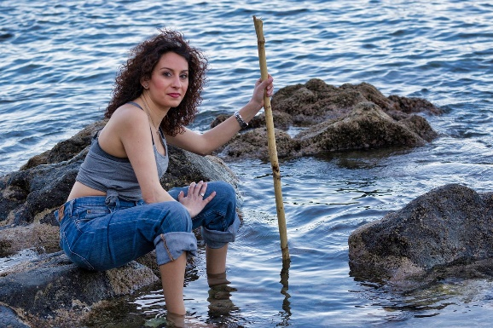
Seaside sorting

Katie is a scientist.
She studies organisms (living things) that live in and around the sea.

Katie took photographs of these organisms at the seaside:
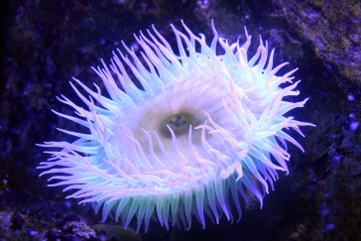
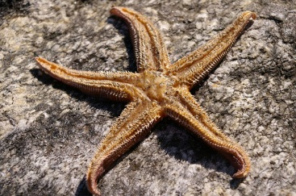
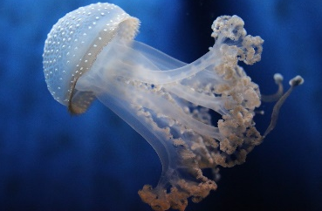
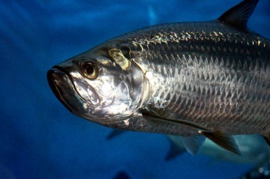
Jellyfish
Fish

Sea anemone
Starfish

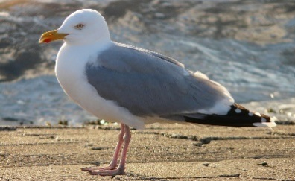

Seagull

Katie wants to sort the organisms into groups.
Why would a scientist sort organisms into the same group?
A | The organisms have similar names.
B | The organisms have similar habitats.
C | The organisms have similar features.
D | I’m not sure.

BEST> Living things and their habitats> Seaside sorting
Diagnostic question
Seaside sorting

Overview
Learning focus: | Organisms can be identified and classified into groups based on their observable characteristics.
Observable learning outcome: | Recall that scientists classify organisms into groups according to similarities and differences in their features.
Question type: | Simple multiple choice, classifying/sorting
Key words: | Classification, features, organisms

Common preconceptions and misunderstandings
This diagnostic question targets the following misunderstandings that pupils might have:
- relying upon organisms’ names to classify them (e.g. misclassifying jellyfish and starfish as types of fish)
- relying upon organisms’ habitats to classify them (e.g. misclassifying penguins and turtles as amphibians because they live both in water and on land).
Although organisms can be sorted into groups according to their names or where they live, pupils should understand that scientific classification is based on similarities and differences in organisms’ observable/physical features.
What to know more? Read What does the research say? towards the end of the Teacher Notes.
Ways to use this question
Children should complete the question individually in order to capture their current understanding. They should be reassured that the question is designed to uncover their thinking and that ‘getting the answer right’ at this stage is not the most important thing. There will be time for them to share and discuss their ideas with others at a later stage.
Provide sufficient time for the children to think and make their decisions. Answers could be recorded formally as a pencil and paper exercise (using the activity sheet) or you could make a ‘card sort’ for them to place into piles; or play a game of ‘corners’ where children physically move to areas of the room displaying response options.
Alternatively, you could use the accompanying presentation with an electronic voting system or mini white boards.
You may want to instruct children to pick just one answer, or you may want to allow them to select more than one. It could be useful to know if they think more than one answer is correct.
Differentiation
You may choose to read the question to the class, so that everyone can focus on the science. In some situations, it may be more appropriate for a teaching assistant to read and/or scribe for a selected number of children.
Expected answers
C – The organisms have some features in common.
Extension
As an extension activity, children could be asked to ‘think like a scientist’ and sort printed images of the organisms into two groups in the way a scientist would do it, and then to explain what made them put some organisms into one group together and other organisms into a different group. What did they think the organisms in each group had in common?
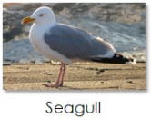  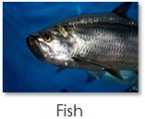 |  | 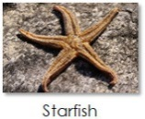  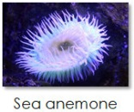  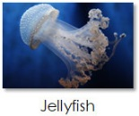 | Scientifically correct  The organisms have been sorted into groups in a scientific way based on physical features (e.g. vertebrate or invertebrate, or another feature such as “has eyes” or “does not have eyes”).
 |  | 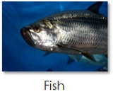 | Scientifically incorrect  Children are likely to be (incorrectly) thinking that all organisms in a group must have a similar name (e.g. “sea-” or “-fish”), rather than being classified into groups according to the organisms’ physical features.
Scientifically incorrect
Children are likely to be (incorrectly) classifying the organisms into groups based on their observable habitat (e.g. land or sea), rather than according to the organisms’ physical features.

Opportunities should also be given for children to explain and justify any additional ways of sorting that they came up with that might not fit into the categories given here. This is a great way to uncover any further preconceptions and misunderstandings.
How to respond - what next?
If there is a range of answers, an effective way to respond would be through structured class discussion. Ask one child to explain why they gave the answer they did; ask another child to explain why they agree with them; ask another to explain why they disagree, and so on until some sort of shared understanding has been reached. This sort of discussion gives children the opportunity to explore their thinking and for you to really understand their learning needs.
Responses often work best when the activities involve paired or small group discussions, which encourage social construction of new ideas (meaning making) through dialogue. Children could record their evolving ideas using the statement: I used to think this . . . . because . . . . and now I think this . . . . because . . . . This is an opportunity for them to evidence any progress in learning.
It would be worth mentioning to children that the example given in the diagnostic question refers to organisms that are living, however, classification is often based on fossils, skeletons and other remains that are no longer living.
If children have further misunderstandings about the criteria upon which biologists classify organisms into groups, it is our intention to link each diagnostic question to a dedicated response activity relevant to primary. In the meantime, we refer you to the existing BEST 11-14 activity, which can be found in the ‘Identifying and classifying organisms’ folder at www.stem.org.uk/best/biology/big-idea-variation-adaptation-and-evolution, and ask you to use and adapt where you feel appropriate.
- Response activity: Classifying into groups
What does the research say?
Research suggests that students sometimes rely upon an organism’s habitat to classify it rather than its physical features; this can lead to misunderstandings and misclassifications, such as that penguins and turtles are amphibians rather than birds and reptiles, respectively (Allen, 2014). Several studies found that students relied upon names rather than features when classifying organisms into groups, such that – for example – jellyfish and starfish would be misclassified as fish (Ryman, 1974; Trowbridge and Mintzes, 1985).
Acknowledgments
Developed by Alistair Moore (UYSEG) and Nicky Waller (CIEC).
Images: woman – pixabay.com/nicolagiordano (3368678); fish – pixabay.com/zoosnow (3686185); seagull – pixabay.com/Hans (57752); starfish – pixabay.com/KRiemer (773758); jellyfish – pixabay.com/Andrea294 (4064588); sea anemone – pixabay.com/Dieter_G (3417960)
References
Allen, M. (2014). Misconceptions in Primary Science, 2nd edn Berkshire, UK: Open University Press.
Ryman, D. (1974). Childrens' understanding of the classification of living organisms. Journal of Biological Education, 8(3), 140-144.
Trowbridge, J. E. and Mintzes, J. J. (1985). Students' alternative conceptions of animals and animal classification. School Science and Mathematics, 85(4), 304-316.

