Nocturnal Animals – Worksheet (touch)

Bag Number | Description | What do you think it might be?

Listen carefully to the animal sounds we are about to play. Once you have listened try to match the sound to one of the pictures below.
Nocturnal animals – Worksheet (hearing)

 | Species  Sperm whale |  | 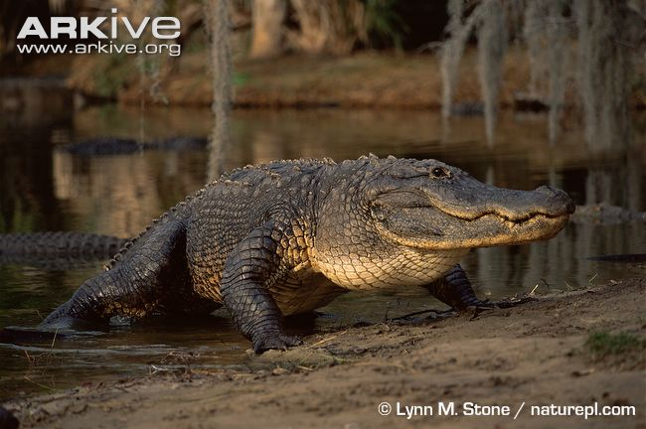 | Species  American  alligator
 | Number |  |  | Number
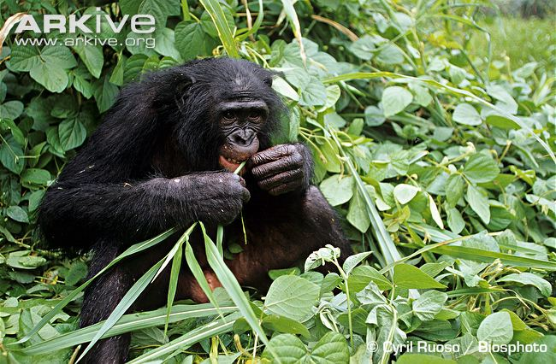 | Species  Bonobo |  | 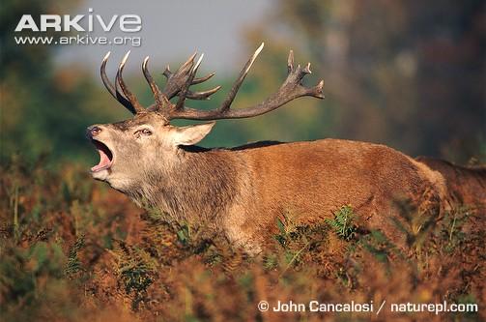 | Species  Red deer
 | Number |  |  | Number
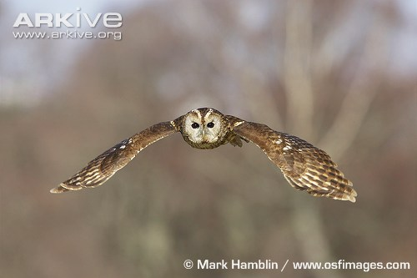 | Species  Tawny owl |  | 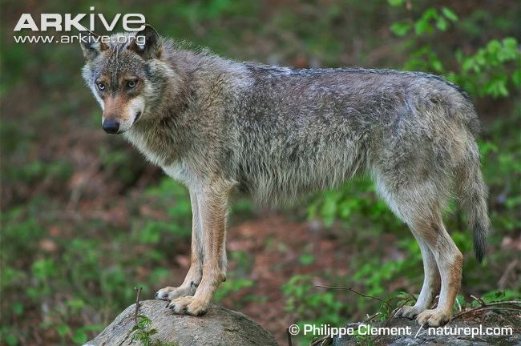 | Species  Grey wolf
 | Number |  |  | Number
 | Species  Common otter |  | 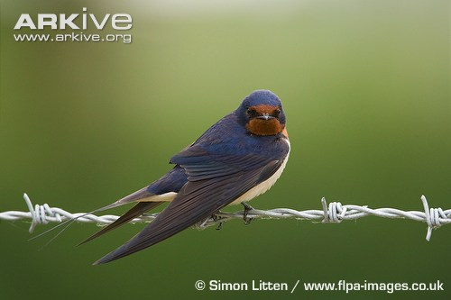 | Species  Barn swallow
 | Number |  |  | Number
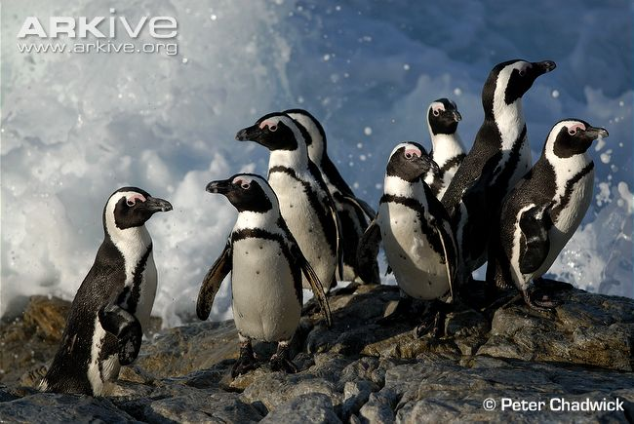 | Species  African penguin |  | 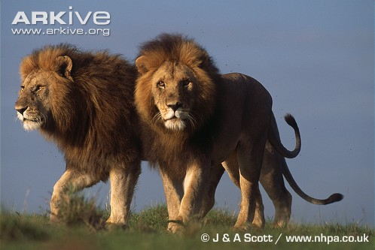 | Species  Lion
 | Number |  |  | Number

(The animals we are going to be listening to are not all nocturnal)

