Listen carefully to the animal sounds we are about to play. Once you have listened try to match the sound to one of the pictures below.
Nocturnal animals – Worksheet (hearing)

 | Species  Sperm whale |  | 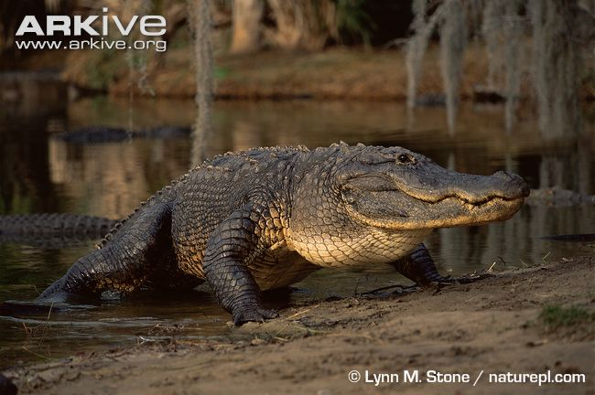 | Species  American  alligator
 | Number  9 |  |  | Number  2
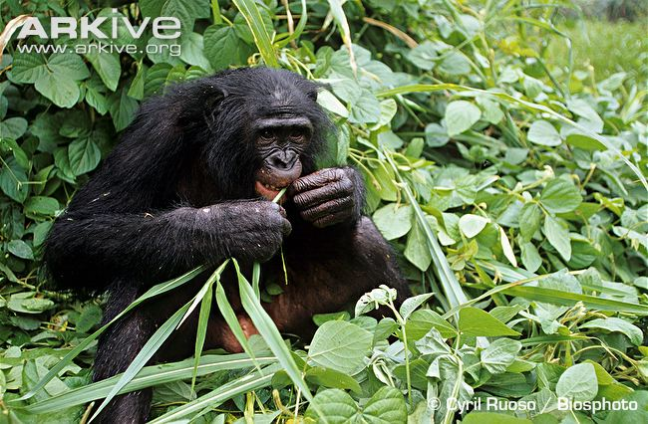 | Species  Bonobo |  | 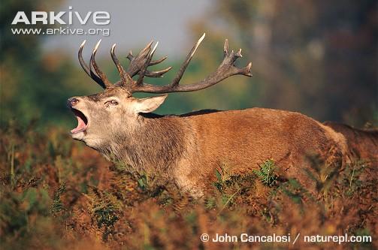 | Species  Red deer
 | Number  4 |  |  | Number  8
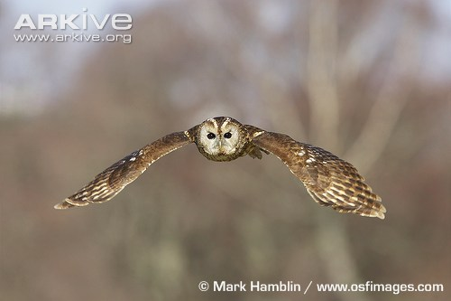 | Species  Tawny owl |  | 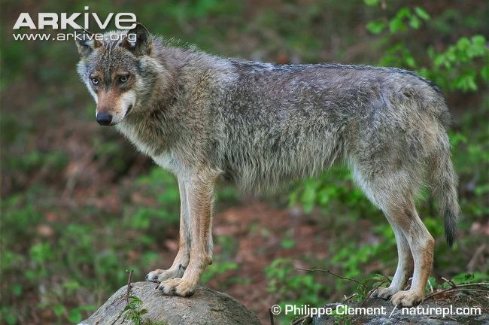 | Species  Grey wolf
 | Number  10 |  |  | Number  6
 | Species  Common otter |  | 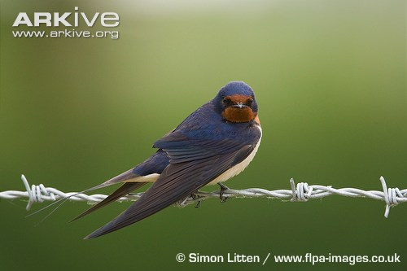 | Species  Barn swallow
 | Number  5 |  |  | Number  3
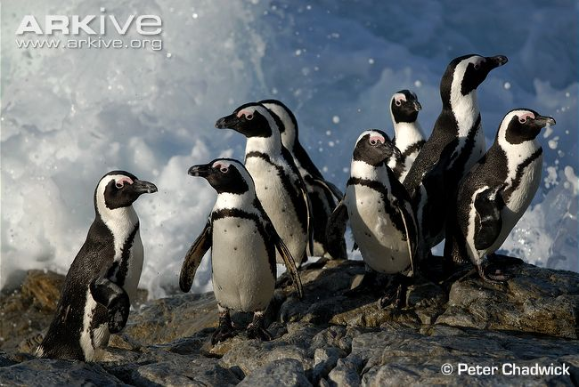 | Species  African penguin |  | 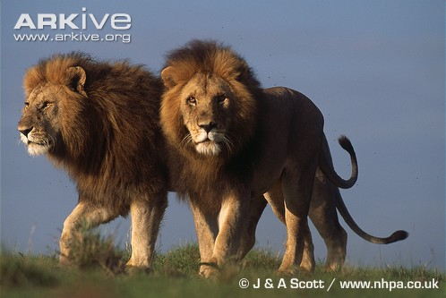 | Species  Lion
 | Number  1 |  |  | Number  7

(The animals we are going to be listening to are not all nocturnal)

