Name(s):__________________________________
Workbook: Mapping for Climate Change

You will be spending today learning about one of the rarest habitats on the planet; lowland heathland. Lowland heathland is rarer than rainforest and supports a large number of different species, some of which are threatened or endangered. You’ll get a chance to have a go at some different ecological survey techniques and will use a GPS unit to map out a conservation area. You might also make some important management decisions that will help the managers of this site to prepare for future climate change.
After today you could be great at:
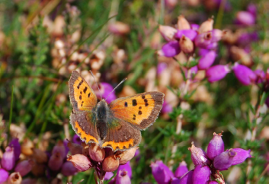
- explaining what a heathland is and why they’re threatened;
- using a GPS unit to mark locations and to map areas;
- using a quadrat to sample vegetation;
- explaining why corridors between sites are really important;
- deciding where to put a habitat corridor
Workbook Contents

Page 2 | Activity A: Orienteering with a GPS unit
Pages 3 - 6 | Activity B: Vegetation surveying
Page 7 | Activity C: Mapping a heathland fragment
Pages 8 - 9 | Activity D: Locating a habitat corridor

Activity A: Orienteering with a GPS unit

Your challenge is to use your GPS unit to create a treasure hunt. Choose five features in the heathland to be in your treasure hunt. The features you choose should be permanent (i.e., not something that will change its location) and relatively large, for example a silver birch tree, or a patch of lichen. Log the co-ordinates of each feature as a waypoint in your GPS unit. If you wanted to you could also write a clue to help people work out what the feature is.
When you have completed your treasure hunt swap your GPS unit with another unit. Using the waypoints saved in their GPS unit and the clues they have written, see if you can find all the features in their treasure hunt!
Feature | Clue
1
2
3
4
5
Remember to log the location of each feature as a waypoint on your GPS unit!
To mark a waypoint:
Press the MENU button twice to get to the main menu.
Move the rocker to highlight ‘mark’, press the rocker to select.
Use the rocker to move up to the waypoint name, press the rocker to select.
Use the onscreen keyboard and rocker to name the point. Press ‘OK’ to end naming.
Use the rocker to move to ‘OK’ at the bottom to save the waypoint
Activity B: Vegetation surveying
In this activity you will be using quadrats to sample the heathland vegetation. You will record which plant species are present in each quadrat, and estimate how much of the ground surface each species covers (i.e., their percentage cover).
Remember, there are three main rules when using a quadrat:
- The quadrat has to be placed randomly;
- You need to decide at the start when a plant will be counted and when it will not;
- You need to be consistent.
How will you make sure that your quadrat is placed randomly?
______________________________________________________________________________
______________________________________________________________________________
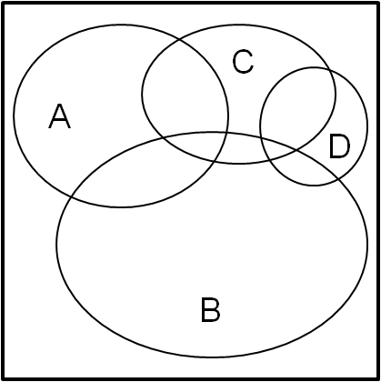
Estimating percentage cover using a quadrat
Look down on the quadrat from above and identify all the plant species that can be found in it. For each species, estimate the percentage of the quadrat that it takes up. For example, in the image on the right you might estimate that species A covers 25% of the quadrat. Species often overlap (as shown in the image on the right) and there may be several different vertical layers of plants. Percentage cover may therefore add up to well over 100% for an individual quadrat.

Use your heathland plant ID guide to help you identify the species in your quadrats. For each quadrat record the percentage cover of each plant species in the table on the following page. Try to complete 10 quadrats!
Fill in this table to show the % cover of each plant type in each of your randomly selected quadrats. At the bottom of the table, you can work out an average % cover of each plant type (by adding up the total in the column and dividing but the number of quadrats you did). Use your GPS UNIT to record the location of each of your quadrats.
GPS location |  | Heather | Bracken | Grass | Moss | Gorse | Lichen | Bareground | Other
Quadrat 1
Quadrat 2
Quadrat 3
Quadrat 4
Quadrat 5
GPS location | Heather |  | Bracken | Grass | Moss | Gorse | Lichen | Bareground | Other
Quadrat 6
Quadrat 7
Quadrat 8
Quadrat 9
Quadrat 10
Average % cover

- A good quality heathland will have at least 25% cover of heather and less than 50% cover of grass or bracken. Using the results you collected in Activity B, explain whether or not you think this is a good quality heathland.
______________________________________________________________________________
______________________________________________________________________________
- Why did you have to do at least 10 quadrats?
______________________________________________________________________________
______________________________________________________________________________
3) Why is it useful to mark the location of each quadrat you did using your GPS?
_____________________________________________________________________________
______________________________________________________________________________
4) Give one possible source of error that may have affected your results.
______________________________________________________________________________
______________________________________________________________________________

Activity C: Mapping a heathland fragment

You’ve practiced marking locations with your GPS unit, now you’ll be using it to map out an area. We’ll be able to put your results onto Google Earth to see the area that you have mapped.

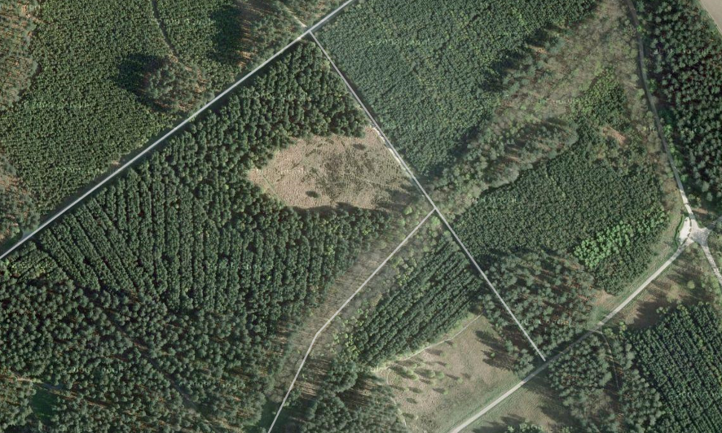
Here is a fragment of heathland within a conifer plantation

Why do you think it might be important for us to accurately map areas of heathland?
______________________________________________________________________________
______________________________________________________________________________
Time to map!
Set your GPS to track your movements.
Walk very carefully around the edge of the heathland.

Activity D: Locating a Habitat Corridor

Climate change means many plants and animals may face extinction unless they are able to move to areas with suitable climatic conditions. For example, as temperatures increase plants and animals may need to move North where temperatures are cooler.
Many organisms will need to move along a habitat corridors. Which types of organism do you think will be most in need of a corridor linking similar habitats?
______________________________________________________________________________
You will be shown three heathland fragments that are not currently linked by a corridor. You will need to decide where the best location will be to place a corridor. You will need to be able to persuade the landowners that they should invest time and money in creating and maintaining a corridor.
- List some things that you need to think about when deciding where a corridor should go.
______________________________________________________________________________
______________________________________________________________________________
______________________________________________________________________________
______________________________________________________________________________
______________________________________________________________________________
- Draw Use the following page to draw an annotated sketch of the area to show where you think the corridor should be located and explain why it should be located there.



