Mapping for Climate Change: Mapping tracks in Google Earth

This information sheet accompanies Activity C of the Mapping for Climate Change resource. It provides instructions on how to display a GPS track in Google Earth.
- Make sure the necessary drivers, if any, are installed on your computer. If you are using a Windows computer and a Garmin USB device that requires USB drivers, install the USB driver from the CD included with your GPS device, or download the driver from the Garmin website (http://www8.garmin.com/support).
- Open Google Earth on your computer.
- Connect your GPS unit to the computer with the serial cable or USB cable that came with the unit. Make sure your GPS unit is turned off when connecting.
- Turn on the GPS unit. You do not need to connect to satellites for this. A new window may appear asking you to install the hardware – select the default options to do this.
- From the 'Tools' menu in Google Earth, select GPS. The “GPS Import” window appears.
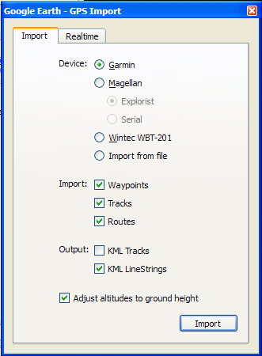
- Under Device, select the correct manufacturer type for your GPS device.
- Under Import, select the types of data you want to import.
- Under Output, select KML LineStrings.
- Check the Adjust altitude to ground height option to adjust all recorded points to ground level.
- Click Import. When your GPS data is finished loading into Google Earth, a confirmation dialog box appears.
- Your data will appear in the Places panel on the left-hand side of the Google Earth screen with the label GPS Device. If you expand the GPS Device folder, you can see your GPS data sorted into separate folders depending upon the type of data, as illustrated in the example below.
- The track can be saved to your Places folder by right clicking on the file name and selecting Save to my places.

