Supported by:
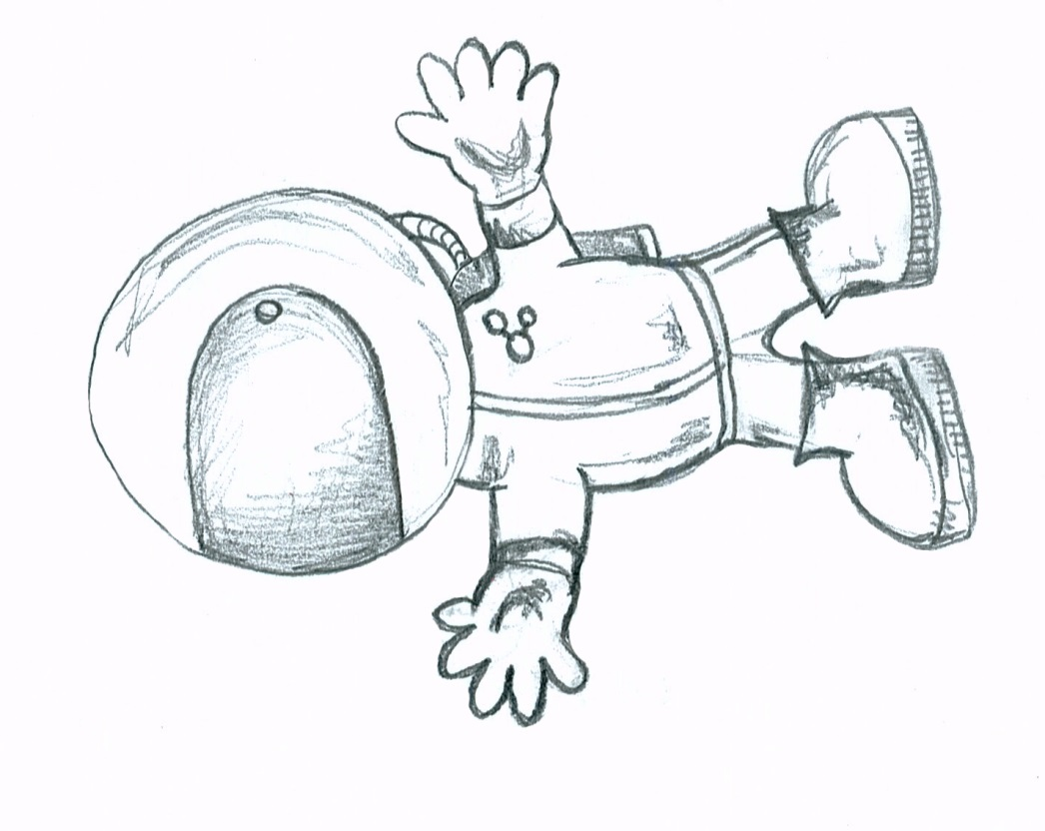
Space Suit Science
Teaching Notes

www.scienceoxford.com/schools
Space Suit Science – teaching notes

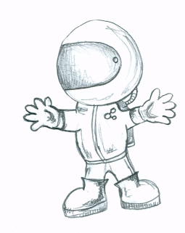

Lesson plans
In this guide we have split the activity into a series of four stages. These can be taught as individual lessons or combined together. We recommend that you leave at least one day between Stage 2 and Stage 3 to allow both you and your pupils time to prepare. The lesson plans should be read in conjunction with the PowerPoint presentation including the notes attached to each slide.

Stage 1 - Finding out about the problem
In stage 1 pupils find out more spacesuits, how they work and why people need them to survive. They also find out more about the challenge to test a series of materials to assess their suitability to be used as part of a spacesuit glove. This competition principally focuses on the insulating layer of a spacesuit.

Stage 2 – Designing their investigations
Pupils brainstorm ways of testing different materials for their ability to insulate. They then settle on one method and plan their experiment. They may also take into account other factors to investigate such as flexibility and resistance to micrometeorite impact. The appendix contains a pupil experiment planning sheet and risk assessment which you may find useful.

Stage 3- Carrying out the experiments
Pupils test their experiment plan to see if it works. They then adapt/change their plan as necessary and carry out their experiment (ideally multiple times)

Stage 4 – Presenting their results
Pupils create an A2 poster of their results which can include photographs, tables, graphs, diagrams etc. They could also prepare a short presentation where they explain what they have done and why, as well as being prepared to answer questions on their investigation.

Stage 1 - Teacher notes
Resources:
PowerPoint presentation slides 1-9 and their accompanying notes
Pens and paper for brainstorming

Ask the pupils to discuss in groups why they think astronauts need to use spacesuits? They might find it useful to think about what space is like and also what people need to survive.

Main functions of a space suit:

- Provide oxygen to the astronaut
- Keep the astronaut from getting too hot or cold
- Provide external pressure on the body to stop it swelling up
- Provide some protection against micrometeorite impact
- Provide some protection against radiation

Please see the notes associated with the PowerPoint slides for more information about these functions.

The space suit science activity focusses specifically on the insulation layer of the spacesuit. The pupils need to come up with an experiment that allows them to test different materials to see how good they are at insulating from heat and/or cold.

Get pupils to discuss the function of insulation. It is important to understand that insulation can be used both to stop things getting too hot and too cold.

In the next stage pupils will begin to explore how they could test materials for their insulating properties.

Useful website:
http://www.nasa.gov/audience/foreducators/spacesuits/home/

Stage 2 – Designing their investigations
Resources:
Powerpoint presentation slides 10-15 and accompanying notes
Experiment planning sheets
Risk assessment sheets
Examples of materials to test (see appendix)
Examples of equipment they will be able to use (see appendix)

Explain the aim of the Space Suit Science Challenge:

Your mission: To design an experiment to test the different materials that could be used to insulate an astronaut glove

Check that pupils understand that they need to devise an experiment to discover how good a given material (or combination of materials) is at insulating something.

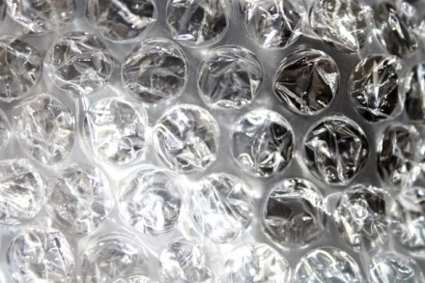
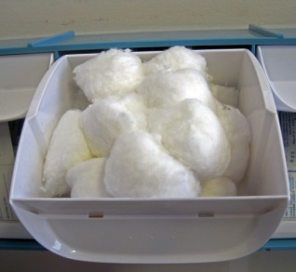
Show the pupils the materials they will be testing for their investigation (there is a list of suggested materials/equipment at the end of this guide). You may also wish to show them the available equipment or the picture prompts on the PowerPoint slide.

Allow the pupils time to brainstorm different experiment ideas in their groups. These do not need to be well thought out at this stage. Get pupils to share their ideas with the rest of the class and discuss the benefits and disadvantages of their possible experiment designs. There are some examples of ways this could be done in the appendix, but pupils should be encouraged to come up with their own ideas.

Emphasise that they will need to devise a way to measure the effectiveness of their insulation. It is likely that the most common ways of doing this will involve them measuring temperature and/or time. Check they know how to use the relevant pieces of equipment (clocks, stopwatches, thermometers, data loggers etc)

Allow pupils more time to plan their experiment and let them know how long they will have to carry out their experiments. This is particularly important for insulation experiments as to measure temperature changes you often need a significant period of time. It may be, however, that they set up their experiment and leave it running over break/lunch/other lessons. You may find it useful to get pupils to fill in the experiment planning sheet and the pupil risk assessment form. In particular, get pupils to draw up a list of equipment that they would like to use.

It is worth specifying a maximum depth of 0.5-1cm for the insulation material(s).
Any deeper and it would be awkward for an astronaut to use as a glove and it also increases the time needed for experiments.

The experiment plan should be agreed with you. Ideally allow them the possibility of using resources that you haven’t supplied, but that they or the school could reasonably get hold of by the next stage (e.g. washing up bowl, empty plastic bottles). Encourage them to plan as much as possible, but remind them that they may need to change their procedure if they discover it doesn’t work as they had planned.

We strongly recommend that you leave at least a day between the pupils planning their experiment and carrying it out. This will allow you to check that they have access to the equipment/space that they need and allow also them to source items from home.
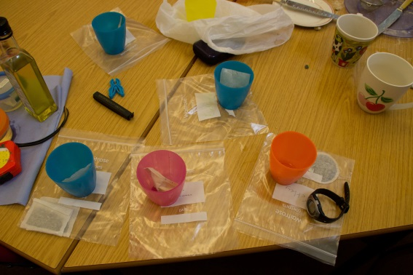
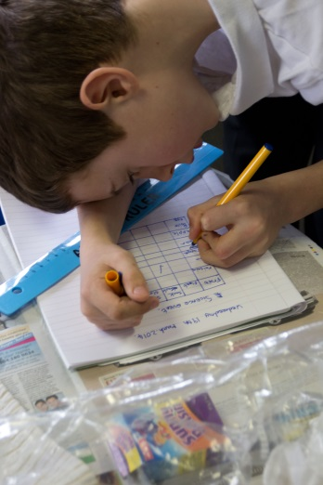
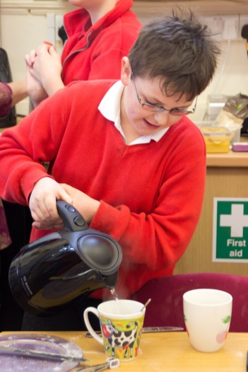

Stage 3 – Carrying out their experiments

Resources:
Experiment planning forms from the previous stage
Paper/pens for recording results
Equipment and materials requested by teams for their experiments
Spare equipment in case of experiment design changes
Additional helpers (STEM ambassadors, TAs, parent helpers)

Get pupils to set up their experiments and decide who in their team is responsible for what. It is likely they will need someone to take measurements and someone to record their results, but they may have other roles like timekeeping, taking photographs, holding equipment etc. These roles could be fixed or team members could take turns in each role.

Ideally, before they run their ‘proper’ experiment, get teams to perform a short test run. This will give them a chance to work out any flaws in their plan and also to think about the things they need to record. In particular they may forget to record information such as the time they started their experiment or the initial temperature reading.

Once pupils are happy with their experimental design, allow them to carry out their experiments.

Pupils often don’t understand the value of running an experiment more than once. If time allows, it is strongly recommended that they repeat their experiments. This has several advantages:

- It allows them to see that science doesn’t always give you exactly the same results every time and that that is normal.
- It allows them to spot results which are significantly different to their other results and think about possible reasons (e.g we read the thermometer wrong, we spilled some of the hot water)
- If their results are very inconsistent, it helps them realise that they may need to redesign their experiment.

Pupils who finish their investigation significantly earlier than other groups can either start work on their poster or create a new investigation to decide the best material for resisting micrometeorite impact.

Make sure that pupils keep their experimental results in a safe place until the next stage.
Stage 4 – Presenting their results

Resources:
Powerpoint Slide 16
A2 paper or card
Graph paper
Experiment planning sheets & results from previous stages
Photographs of their experimental set up
Decorating materials – coloured pens/paper/glue/scissors etc

Pupils could create an A2 poster about their investigation and prepare a short presentation on what they did and why.

Things to include on the poster and/or presentation

- A Title
- Names of team members / team name
- Some information about space suits
- Some information on insulation
- Which materials you tested
- How you tested them
- Why you tested them that way
- What you found out
- Anything that surprised you
- Anything you would change if you did the experiment again
- Which material(s) you would use for an astronaut glove

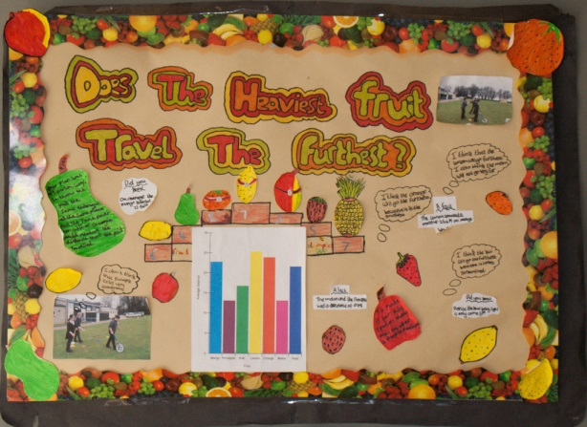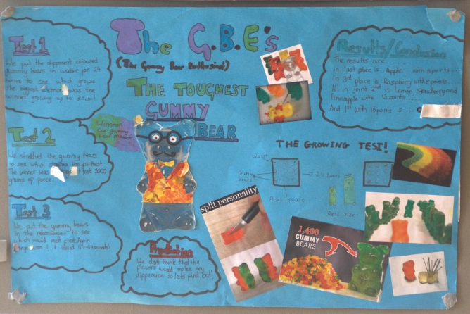

Appendix 1
Recommended resources for experiments

Test materials
These are some possible materials to use to test for an astronaut glove. You will not need to provide all of these materials, just a selection of them. Feel free to add your own materials to this list.

Paper towels
Cloth (e.g teacloth, J-Cloth, old clothes)
Paper
Corrugated card
Tin foil
Mylar (survival/first aid foil blankets are made of this)
Sponge cloths (type used for washing up)
Plastic (e.g plastic bags of various thicknesses)
Bubble wrap
Leather
Newspaper
Cling film
Cotton wool

Experimental Equipment

Challenge specific
Thermometers and/or data loggers that can record temperature
Stopwatches
Ice / Ice packs / fridge / freezer
Hot water bottle / heat packs / kettle
Beakers / Cups / Measuring cylinders / Screw top bottles
Latex/Rubber gloves

Generally useful
Paper/ pens/ Lolly sticks / Card / Tape / Straws / Rubber bands / Bulldog clips / Rulers / String / Paperclips / Plasticine / Blu tack / Scissors / Construction kits e.g. lego/k’nex / stapler / thread / trays

Appendix 2

Example investigation set ups

We have included some possible ways to set up an investigation to test insulation materials. Ideally the pupils will come up with their own ideas, but it may be useful to be aware of these to help you guide pupils who are stuck.

For all of these examples we are assuming that pupils are testing 4 different materials. However, pupils may test a different number or test combinations of materials (e.g a layer of bubble wrap with a layer of cotton wool).

- Set up 5 identical containers (e.g. cups/beakers/bottles). Four that are each insulated with a different material and one without anything. Fill each of them with hot water (ideally at the same temperature) and measure the temperature every 5 minutes for 20-30mins.

- Set up 5 identical containers (e.g. cups/beakers/bottles). Four that are each insulated with a different material and one without anything. Fill the containers with identical quantities of ice. Leave it for 20-30 mins and measure how much or the ice has melted (by weight or volume)

- Set up 5 identical containers (e.g. cups/beakers/bottles). Four that are each insulated with a different material and one without anything. Fill the containers with identical quantities of ice. Check it regularly and measure how long it takes for the ice to melt completely in each of the containers.

- Place 4 identical icepacks on the table and place the same thickness of test material on each of them. Measure the temperature below and above the insulation layer every 5 minutes for 30 minutes.

- As above, but use heat packs or hot water bottles instead.

- As in 4 or 5 but wrap the heat pack / ice pack with the material and measure the outside temperature.

- As in 5 but place an ice cube on each of the samples. Measure how long it takes for each ice cube to melt completely.

- Set up 5 identical containers as in 1. Fill each of them with water (ideally at the same temperature) and place in a freezer. Measure how long it takes for the water to freeze in each container.

Experiment Planning Sheet
Names of people on your team:

What materials will you test?
How will you set up your experiment? Write a description or draw a labelled diagram

How will you keep it fair? What things will you keep the same?

What will you measure? e.g. Temperature, time, counting things etc
What will you use to measure it?

How many times will you repeat each experiment?
How much time do you think it will take for each experiment?
Can you run more than one experiment at a time?
How will you record your results?
Tally, table, photo etc
What equipment do you need?
Where can you get it from?
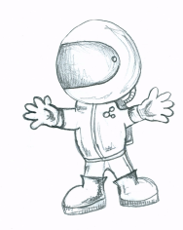

How will you display your results?
Bar chart, graph etc
Have you filled in the risk assessment sheet? |  |  |  |  | Yes |  | No

Pupil Investigation Risk Assessment
Investigation title | Experiment to discover the best insulating material for a space suit glove
People in the team | 1.
 | 2.
 | 3.
 | 4.
 | 5.
What might be dangerous? |  | Who might it be dangerous for? | How we will make it safer.
1.

2.

3.

4.

5.

www.scienceoxford.com/schools
Space Suit Science by Science Oxford is licensed under a
Creative Commons Attribution-NonCommercial-ShareAlike 4.0 International License

